

**Image degradation tool for synthetic dataset**

User Manual

# **Table of Contents**

1. ***Introduction***

1.1 Overview

1.2 Purpose of the Document

1. ***Installation and Setup***

2.1 MATLAB Installation

2.2 App Files

2.3 Launch MATLAB

2.4 Open the App

1. ***User Interface Overview***

3.1 Sections and Parameters

1. ***Operating Instructions***

4.1 Launch the App

4.2 Select source and destination options

4.3 Tick all checkbox

4.4 Tick preset checkbox in CCM matrix panel

4.5 Execute

**1. Introduction**

**1.1 Overview**

The image degradation tool is a versatile tool designed to automate the creation of degraded image dataset. These datasets are essential for developing, testing, and benchmarking computer vision models, especially when real-world image datasets are difficult or expensive to obtain.

**1.2 Purpose of the Document**

This document serves as the User Manual for the image degradation tool. The purpose is to guide users through the initial setup, configuration, and operation of the system. The manual provides comprehensive instructions for generating degraded image datasets with varying characteristics, which are crucial for testing and comparing different computer vision models and approaches.

**2.** **Installation and Setup**

**2.1 MATLAB Installation**

Ensure that MATLAB is installed on your computer. The app should be compatible with most recent versions of MATLAB.

**2.2 App Files**

Obtain the app files from your source and ensure they are placed in an accessible directory.

**2.3 Launch MATLAB**

Open MATLAB and navigate to the directory containing the app files.

**2.4 Open the App**

Run the script to launch the Image degradation tool. This can typically be done by typing the script name in the command window.

**3. User Interface Overview**

The user interface is divided into several sections, each corresponding to different noise and degradation settings. Below is a detailed description of each section and its parameters.

The following image illustrates the user interface:

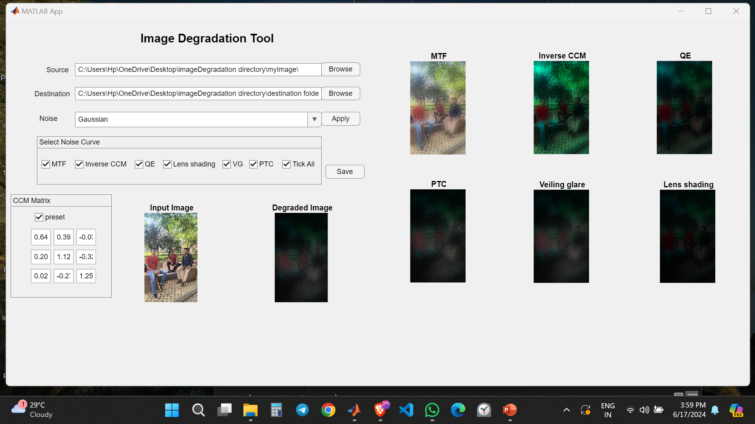

**3.1 Sections and Parameters**

Prerequisite:

You must have the MTF.xlsx and the PTC.csv file in your directory before running the app otherwise it will throw an error.

**Download it here:**

PTC: [Here.](https://docs.google.com/spreadsheets/d/e/2PACX-1vR06zXgIOiH7baWajLJ9-ee846fWBNE_3phKReRppnkwAUx1jXR2ALv7kYZ3qfj_XzYIZQl7TnwHt69/pubhtml)

MTF: [Here.](https://docs.google.com/spreadsheets/d/e/2PACX-1vStMMziAhrlopuceqyQKIrxILlDHVT-_3wwf70hlxbA0ahqXs47s5eGXq6zBWPjKGdXxr_C-ZE3sFwY/pubhtml)

General Options:

* **Source**: A section to define our source directory where the original undegraded images exist.
* **Destination**: A section to define our destination directory where the degraded images will be stored after processing.
* **Noise:** A section to add a noise to the original image before entering into the degradation pipeline.
* **Apply button:** To apply the chosen noise to the image.

Note: Click the apply button of the noise section before hitting the save button of the degradation pipeline.

1. Select Noise Curve panel:

* Checkbox (MTF): Enable or disable the application of modulation transfer function(MTF).
* Checkbox (Inverse CCM): Enable or disable the inverse CCM.
* Checkbox (Quantum Efficiency[QE]): Enable or disable the quantum efficiency.
* Checkbox (Lens Shading): Enable or disable the lens shading settings.
* Checkbox (Vailing Glare): Enable or disable the vailing glare settings.
* Checkbox (PTC): Enable or disable the photon transfer curve settings.

1. CCM matrix panel:

* Checkbox (Preset): To enable preset CCM(3x3) values for applying inverse CCM.
* There is also flexibility to provide your own CCM matrix by changing the values in the edit fields.

Note: Click the preset or provide your own values in the edit fields before clicking the save button otherwise it will take the (3x3) zeros matrix.

**4.** **Operating Instructions**

**4.1 Launch the App**

* Launch MATLAB on your computer.
* In the command window, type ‘appdesigner’ to launch the GUI.

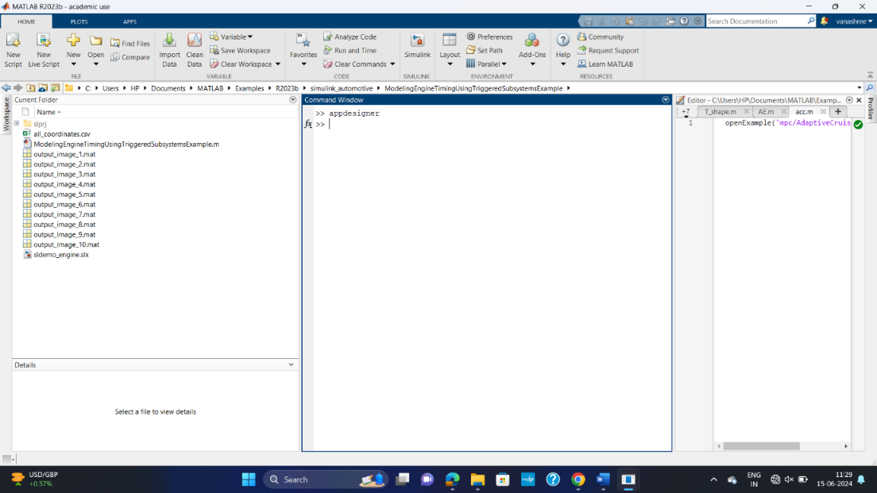

* In Designer view, click "Open" to launch the appropriate app for accessing the required GUI.

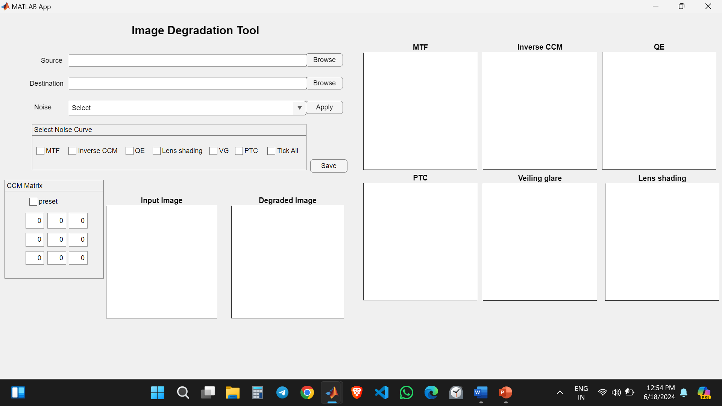

**4.2** **Select source and destination options**

* Select the source and destination of where the images will be taken from and saved after degradation.



* Select the type of noise you want to apply for the image and click apply button.

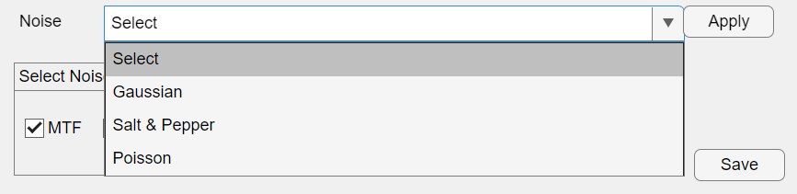

Note: Click the apply button of the noise section before hitting the save button of the degradation pipeline.

**4.3 Tick all checkbox.**

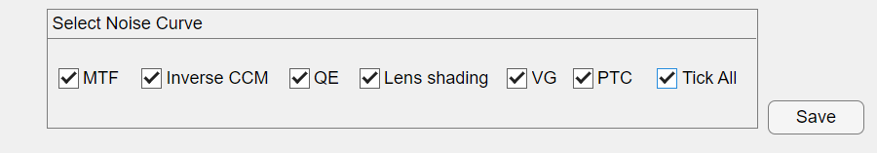

Use tick all check box to select all the checkboxes that apply in degradation pipeline.

**4.4 Tick preset checkbox in CCM matrix panel**

Click the preset check box to apply the existing matrix values, otherwise you have to provide your CCM values to in the edit field.

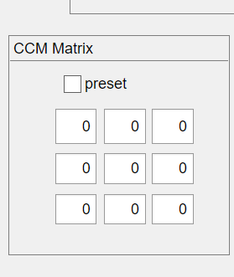 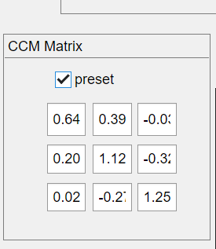

Note: Click the preset or provide your own values in the edit fields before clicking the save button otherwise it will take the (3x3) zeros matrix.

**4.5 Execute**

Click the save button if you followed all the previous process to degrade the images.

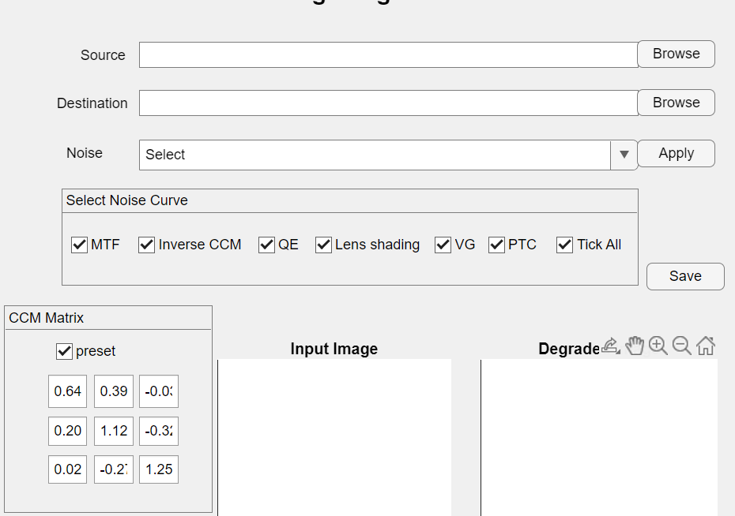

Generated degraded output:

This is the output from the GUI after following all the procedure.

